
BUDGET WIZARD System Access via WebWiz
Inventory Closeout procedures

Please find herein the information required for you to affect inventory availability changes to the Wizard System (Close outs)).

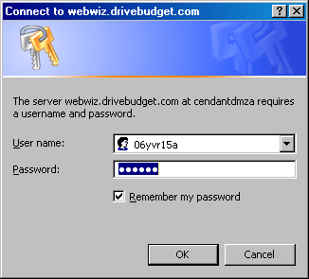
Getting into Wizard via your PC.

You Wizard session is accessed through a internet based program called WebWiz

Click on the link below to access WebWiz

https://webwiz.drivebudget.com

Once connected you will get the sign on screen.

At User Name type in:
Password:

Enter your login information, click OK and you will arrive at the Webwiz Login Screen

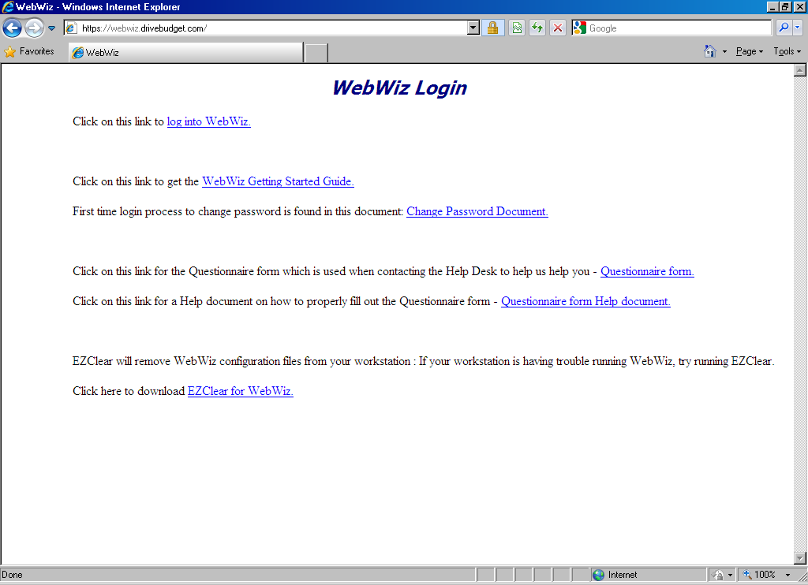
Click on: log into WebWiz

Webwiz will load a Wizard session and a printer session. Last screen to appear will be your printer session. It will be titled at the top P2-budget-HC-print-v1 - BlueZone Mainframe Printer.

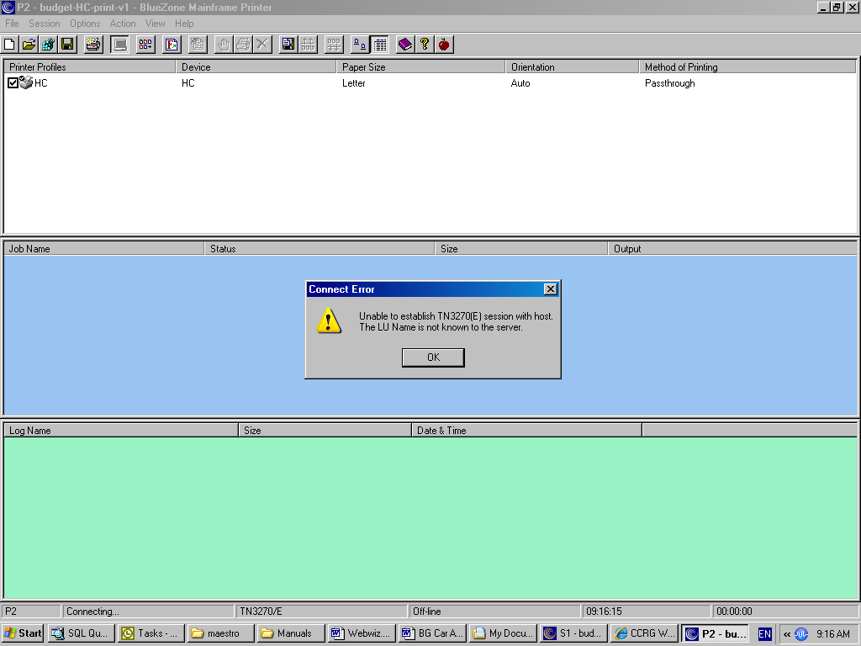

Ignore and close the error message. To access Wizard click on S1 (session 1).

The mainframe screen appears as shown below.

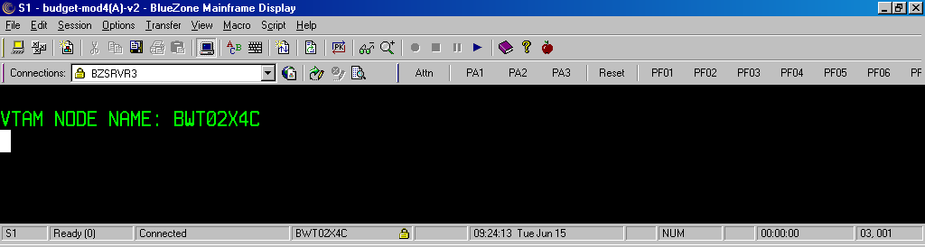

Type in bims – press enter (either right control or numeric keypad enter)

The following screen will appear

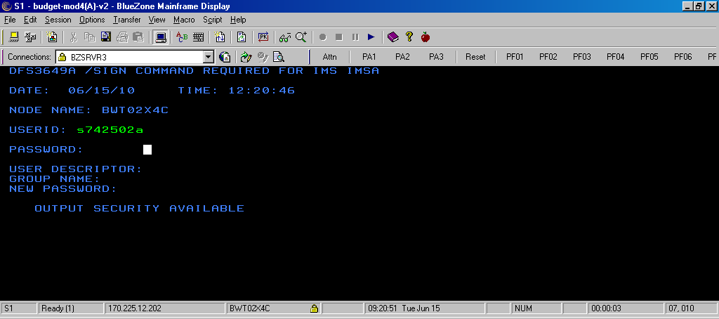

Your Wizard USERID s742502a
Your Wizard PASSWORD yvr469 (hidden as you type)

- Enter command to go to different Maestro screens. For instance, to view reservation, enter /for b502.

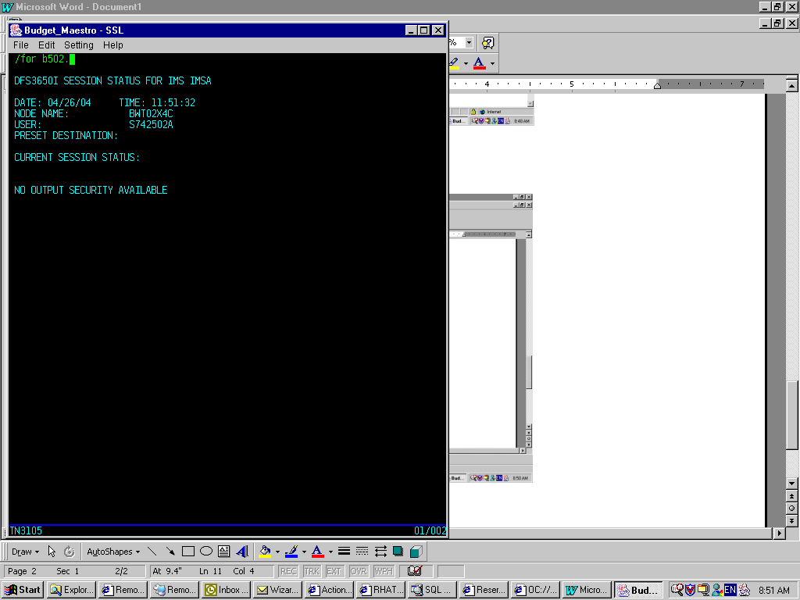

Print b502 report

- Type /for b502. to go to reservation screen.
- Type qr or dr in the first field at the left handed top corner.
- In the NAM field, type in r/maestro_rez_num.

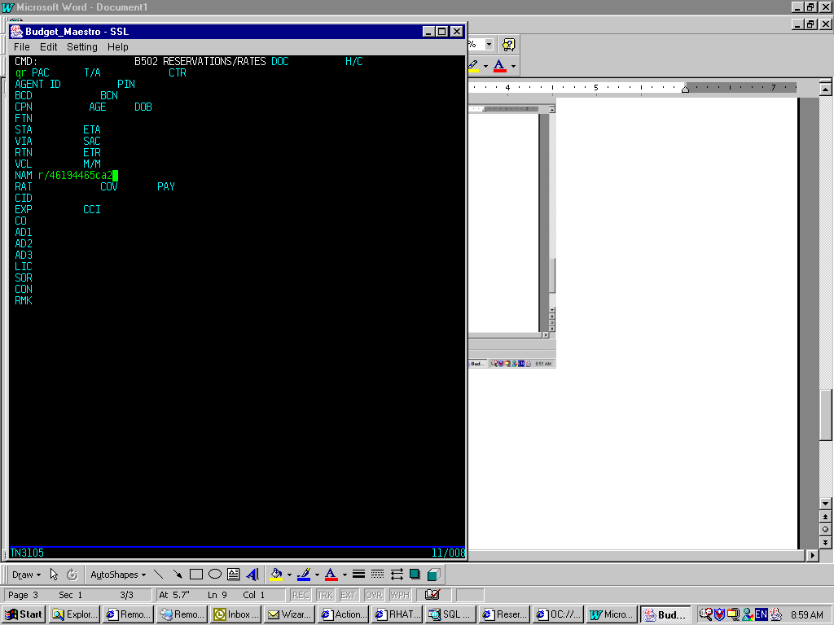
- Press Enter to retrieve reservation.
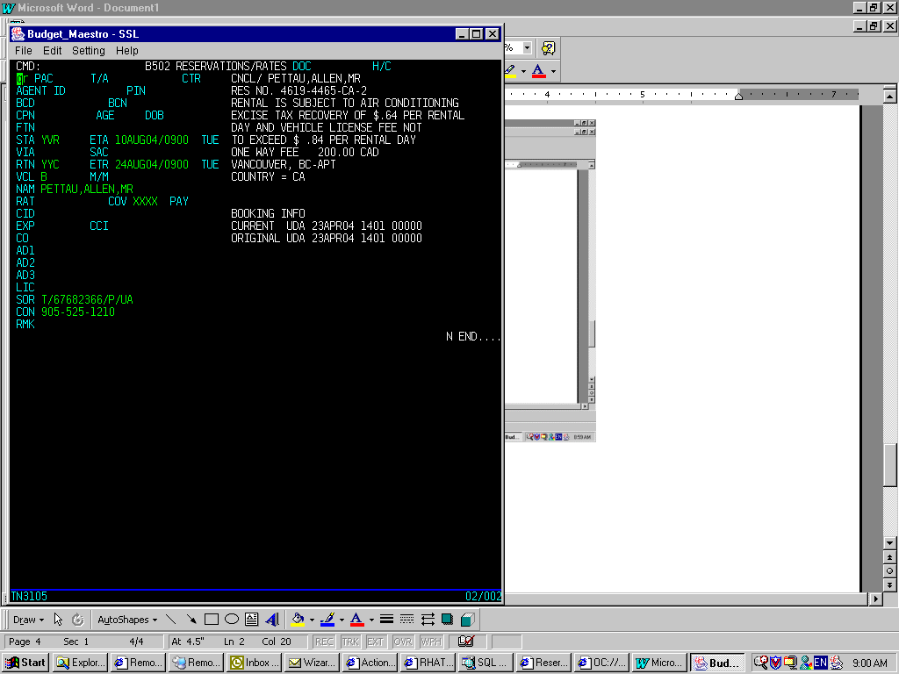

- Verify the confirmation number on the right-handed top corner. Sometimes, Maestro will display an old reservation, press enter again to re-submit the command.

Log off Maestro terminal

Note: Always remember to log off Maestro terminal properly before you close all browser. This helps to avoid displaying old reservation.

- Press Home to go to the CMD field.
- Type /end. and press Enter.
- Wait for the message “…END COMMAND COMPLETED”, then you can close the browser.

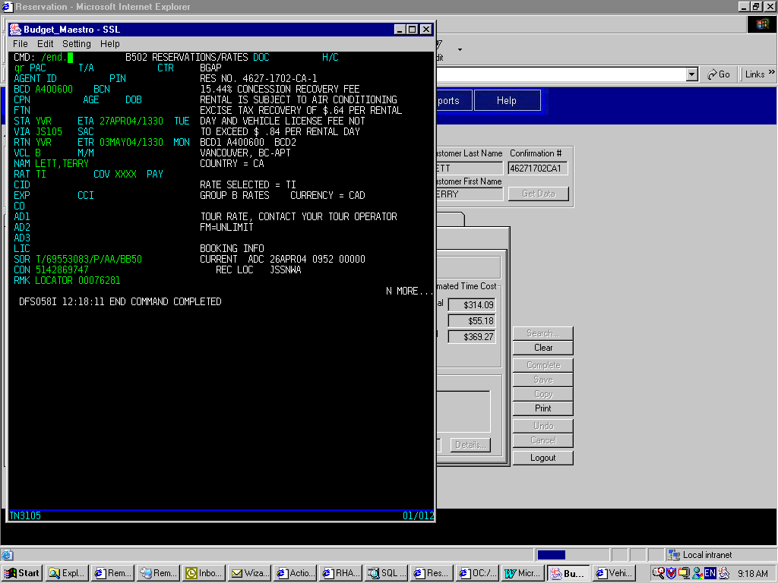
- Or you can type /rcl to clear the current session and go back to the VTAM screen to re-logon again.
- Whenever Maestro does not work properly, end the session (/end.), clear it (/rcl.) and re-logon.

Tips

- P: After I logon, I cannot go to the b502 screen or any other screens.
S: Use /end. and /rcl. respectively to end and clear the session properly, then re-logon again.

- P: When try to retrieve a reservation, another reservation is displayed instead.
S: Press Enter again. If it still does not work, end, clear session and re-logon again.

- P: I was being very fast and keep typing some keys or Enter. However, there is no response and
whatever I type does not display.
S: Check the status bar at the bottom of the screen. If you see the message “…X WAIT”, it means the system is busy and please wait. Wait until the message disappears before you continue typing. If problem persists, check the network.

- To advance to next page, use Ctrl + F1 keys.
- To print screen, go to File/Print Screen.
- To copy, select text and go to Edit/Copy. In this case, Ctrl + C will not work.

